# Alchemy Escape Hall Effect Sensor

The alchemy escape hall effect sensor is capable of detecting magnet rotation as well as distance. It is based on the Allegro [ALS31300](https://www.allegromicro.com/-/media/files/datasheets/als31300-datasheet.ashx).

# Wiring

The sensors can be chained together using **parallel** 4 pin JST PH cables. The length of all cables should not exceed ~1 meter. See section on extending I2C for using the sensors at greater distances.

See HallSensorWiring.pdf for detailed wiring diagrams.

# Integration

### Rotational Detection Type

Magnets used for rotational detection need to be diametrically magnetized.

[Here](https://www.kjmagnetics.com/proddetail.asp?prod=R834DIA) is a recommended magnet for rotational use.



### Placement Detection Type

Magnets used for placement detection need to be axially magnetized.

The ½” x ½” N52 magnet [here](https://shop.escaperoomtechs.com/products/magnets?variant=39931183431886) is a good choice for placement use.

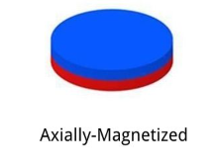

### Construction

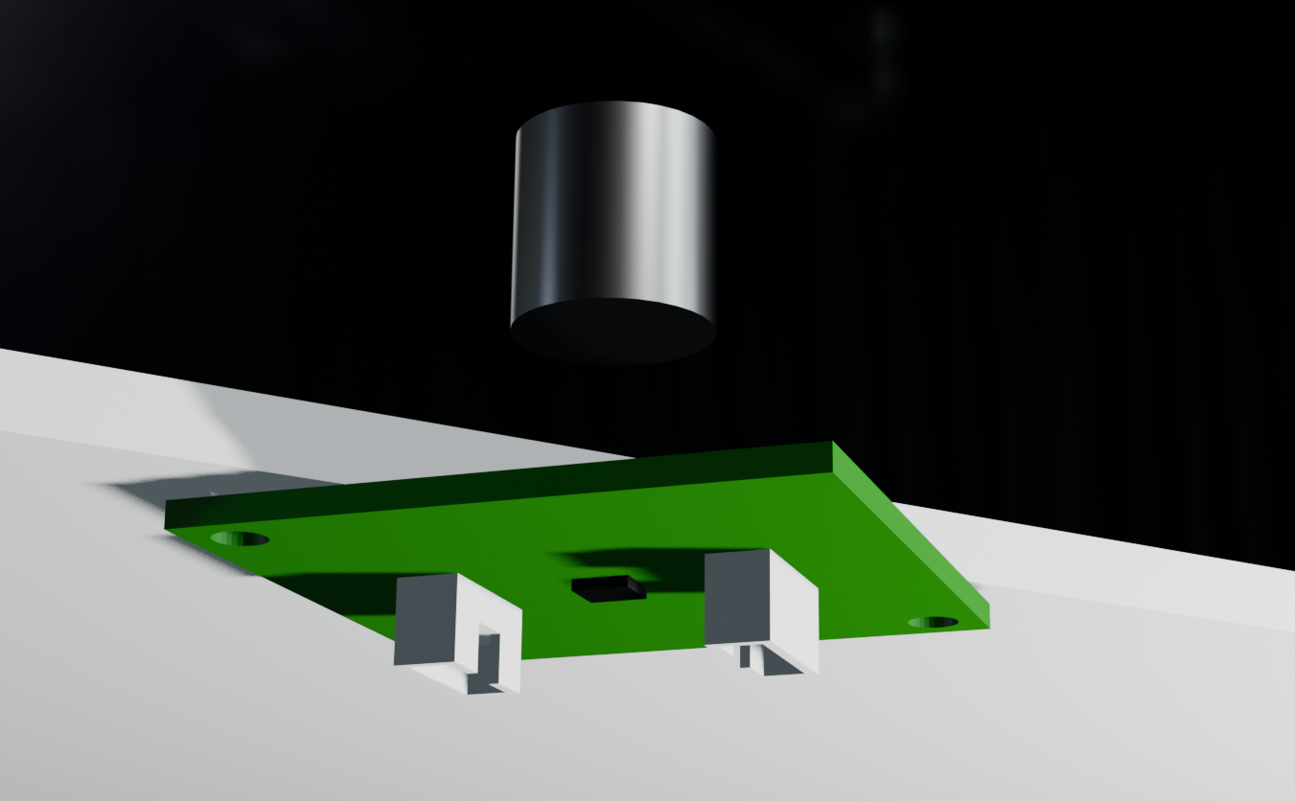

Sensor should be mounted to a flat surface on the underside. Magnet should be embedded in the prop or on a shaft depending on the detection type.

# Address Programming

Each sensor needs to be programmed with a unique address on the bus. By default, the sensors are programmed with address 0 from the factory. If there are 4 sensors on a bus, you may program them with addresses 1, 2, 3, and 4 for instance. I2C addresses range from 0-127.

**BAC Compability Note:** the BAC expects these sensors to have addresses 96-111

## Source

The [source code](https://github.com/Alchemy-Escape-Rooms-Inc/HallSensor) runs on an ESP32-S3. By setting the old address and new address you can program the sensor. The program will attempt to set the device address on boot.

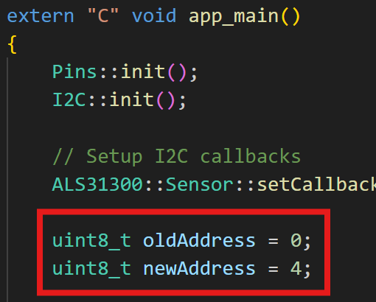

Here is the output of the example address programming above. First the device is programmed, and then after a power cycle it shows up at address 4.

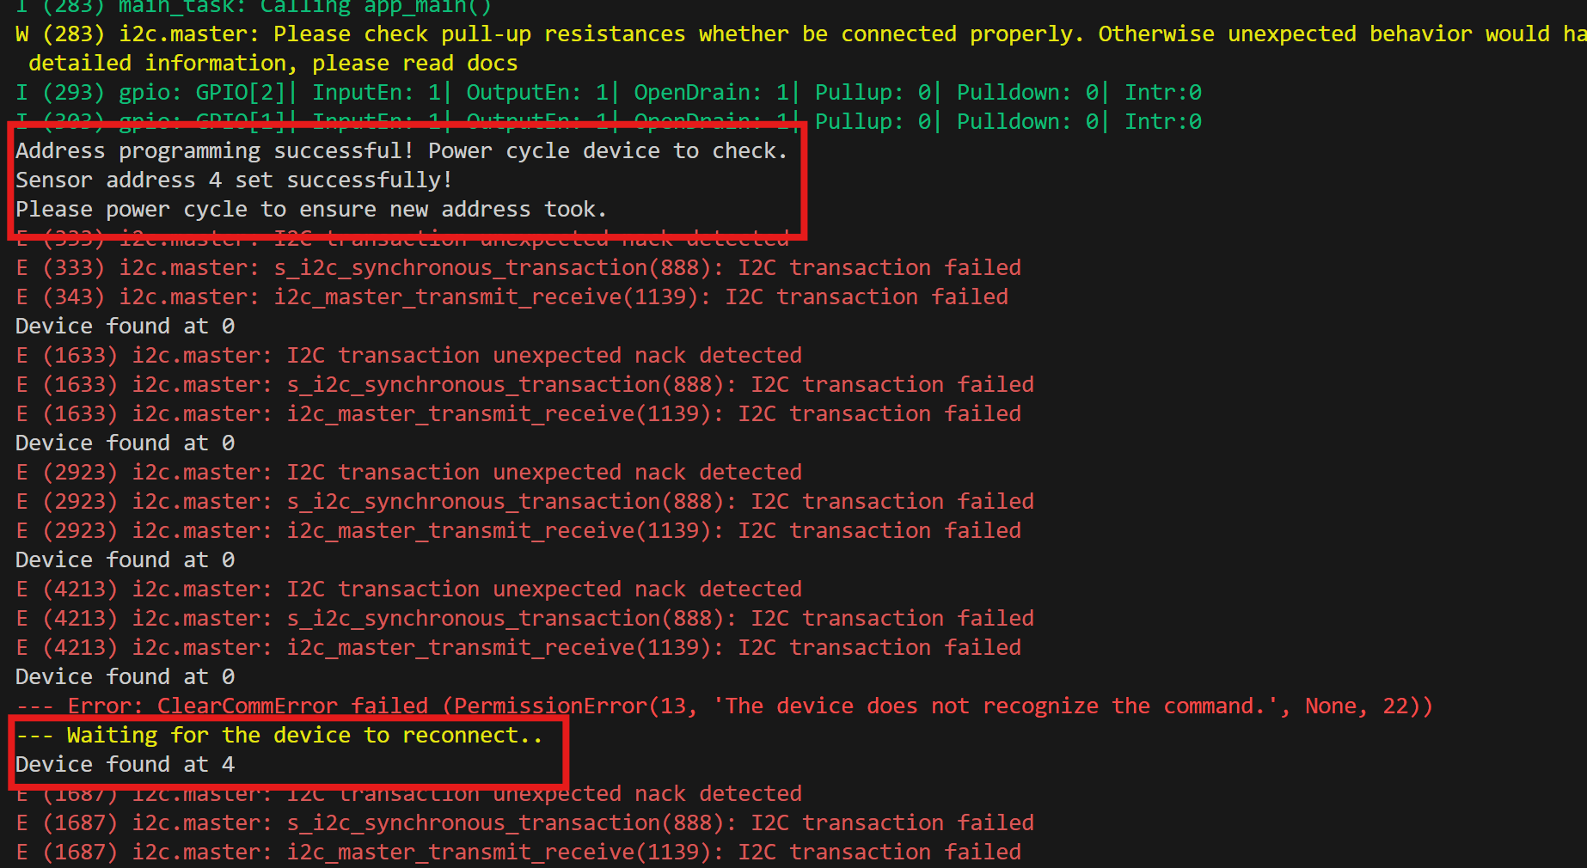

# Extending I2C

I2C has a max cable distance (end to end with all sensors) of roughly one meter. You can increase the distance by using lower value pullups / dropping transmission speed to get roughly double the distance. If the distances are much larger, you need to use an I2C extender. The [FX14-mini](https://shop.escaperoomtechs.com/products/i2c-range-extender-fx14-mini) by Escape Room Techs can accomplish this.